I usually go about HTML, CSS and JavaScript as follows, when talking to friends/family who have no clue:

If front-end was a human being…

HTML = Skeleton (elements, content, layout, structure)

CSS = Skin (styling, appearance, aesthetic)

JS = Muscle and blood that makes the body alive, enables the body to move. (dynamic,

interactive)

Back-end would be the brain that does computations and gives logic to the body’s behaviors.

Database would be the human memory.

And then I tell them that I do backend which is everything you don't see lol.

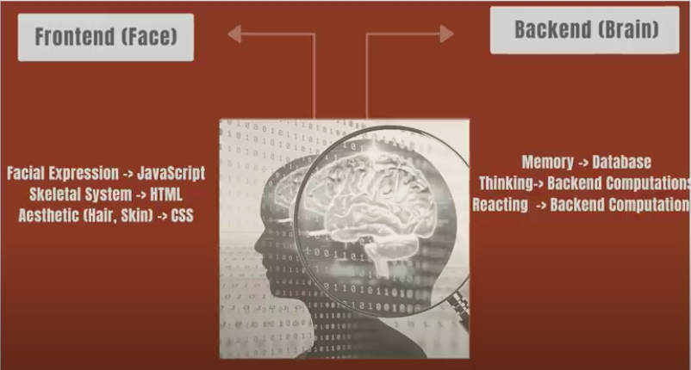

**How the Front-End and Back-End Communicate With Each Other**

There are generally two ways that the front-end and back-end communicate with each other. The first: through a HTTP request to the server which responds back with browser-ready code like HTML, CSS, and JavaScript. Once the website has loaded, any CRUD (create, read, update, destroy) methods used for querying data will then be updated on the back-end, and either displayed via front-end coding or not at all if it isn’t relevant for the user experience.

And the second is through the use of AJAX: This is the more modern, popular choice for communication between each side. This done by using REST (Representational State Transfer) and asynchronous communication. HTTP requests are sent in JSON form (JavaScript Object Notation), and the entire webpage does not have to refresh in order to update small components of the site.

